INTERDIGITATED ELECTRODES IN MICROFLUIDICS

Omar Mahmood

**High-Pass Filter Subsystem Report**

**Table of Contents**

List of Figures …………………………………………………………………………………..

List of Tables ……………………………………………………………………………………

1. Introduction ……………………………………………………………………………..

2. Theory …………………………………………………………………………………..

3. Design …………………………………………………………………………………..

4. Operation ……………………………………………………………………………….

5. Data Collection …………………………………………………………………………

6. Conclusion ………………………………………………………………………………

6.1 Learnings …………………………………………………………………………….

6.2 Future Works …………………………………………………………………………

**List of Figures**

Figure 1: Diagram of high-pass filter ……………………………………………………..

Figure 2: Conceptual Scope of High-Pass Filter ………………………………………….

Figure 3: COMSOL simulations of electric fields at 10um spacing and width …………..

Figure 4: Bonded Device with proper alignment under a microscope ……………………

Figure 5: Top view of bonded device ……………………………………………………..

Figure 6: Experimental setup from the left ……………………………………………….

Figure 7: Experimental setup from the right ………………………………………………

Figure 8: Droplets being sorted using the device ………………………………………….

**List of Tables**

Table 1: Table of experimental results ……………………………………………………..

**1. Introduction**

The purpose of this document will be to discuss the High Pass Filter Subsystem of the overall Microfluidic Parser. The High Pass Filter focuses on the separation of larger droplets (100 um+) from the smaller droplets. This subsystem is the vital precursor to the band pass filter, and contributes to the main output of the parser, a series of uniform droplets with no satellites. This report will cover aspects such as theory, design, operation and data collection.

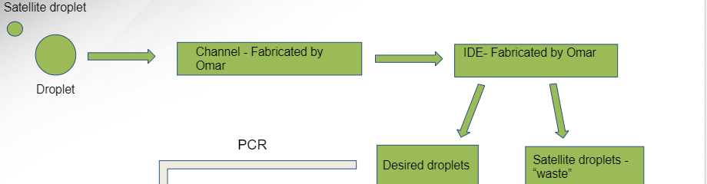

*Figure 1: Diagram of high-pass filter*

**2. Theory**

The scope of this subsystem was to create a method for separating larger droplets from smaller ones. These larger droplets would then be fed into an intermediate PCR process. This involved designing and creating a microfluidic channel and an Interdigitated Electrode Array (IDE). For the purposes of this presentation, the fluid would be a water-based solvent, biased by a diluted surfactant. The IDE chosen had fingers that were 10um wide and spaced out by 10um. This was based off of simulations conducted on COMSOL, which indicated that the electric field produced by these dimensions would be sufficient enough to separate droplets. The droplets would reach the IDE, which would be charged by a voltage of around 200mV, creating an electrical field. This field would direct larger droplets into a specialized outflow channel and would direct the smaller droplets into a waste channel.

The original high pass filter contained an integrated droplet generator. This meant that droplets would be generated from the channel itself. However, this was altered to using a third party specialized droplet generator. This generator provided more uniform droplet sizes. These droplets were then fed into the input of the high pass filter.

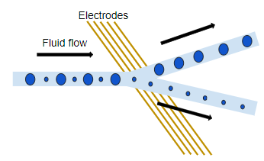

*Figure 2: Conceptual Scope of High-Pass Filter*

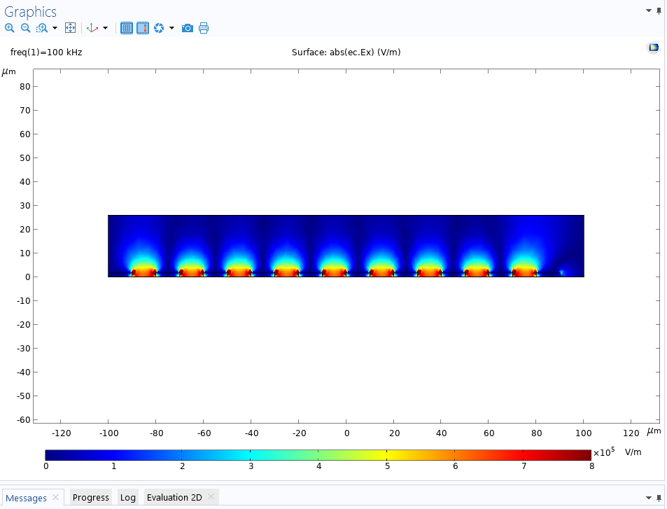

*Figure 3: COMSOL simulations of electric fields at 10um spacing and width*

**3. Design**

To begin, we will mention the hardware that was utilized in the high pass filter. A microfluidic channel was first designed and fabricated for the droplets to move through and for the experiment to take place. The channel was designed to have a height of 120um to facilitate droplet movement. The channel contained some slopage for the outputs, so height varied slightly. These channels were designed in AutoCAD, and then 3D printed onto a silicon wafer using a NanoScribe machine. Once printed, the wafers underwent a soft-lithography treatment utilizing PDMS. PDMS was spread over the wafer, baked at 70 degrees Celsius, and then brought out, cut and holepunched. This soft-lithography was undergone multiple times to produce multiple channels.

To create the IDE, a nanofabrication cleanroom facility was used. A gold-deposited slide of glass was used to begin with. A mask of the IDE was placed over and etched into the slide. The slide then underwent processes such as photolithography, wet-etching and Plasma Enhanced Chemical Vapor Deposition (PECVD) in order for it to be completed. Once completed, the IDE was ready to be bonded to the channel.

To bond both devices together, a plasma bonder was used. Both the IDE and the channel underwent a treatment with oxygen plasma. Once ready, a microscope was used to align the IDE to the part of the channel where the sorting would happen. The terminals of the IDE were then soldered to wires, which would be connected to the power source supplying 200mV-500mV.

To begin the experiment, some third party equipment was used. A droplet generator was used to generate the droplets. Three electronic syringe pumps were used. One was used to pump droplets, two were used for fluid biasing using a diluted surfactant solution. Droplets were pumped and biased, and once they reached the IDE, the voltage induced an electric field, which separated the droplets based on size.

*Figure 4: Bonded Device with proper alignment under a microscope*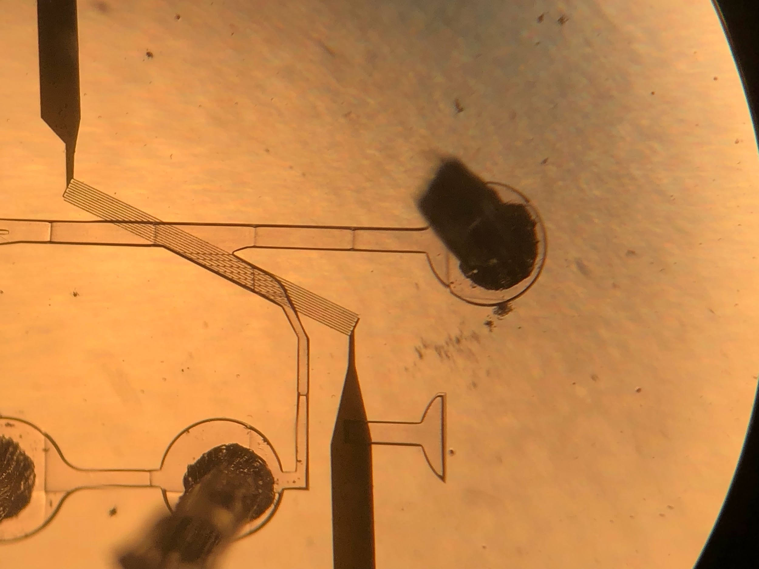

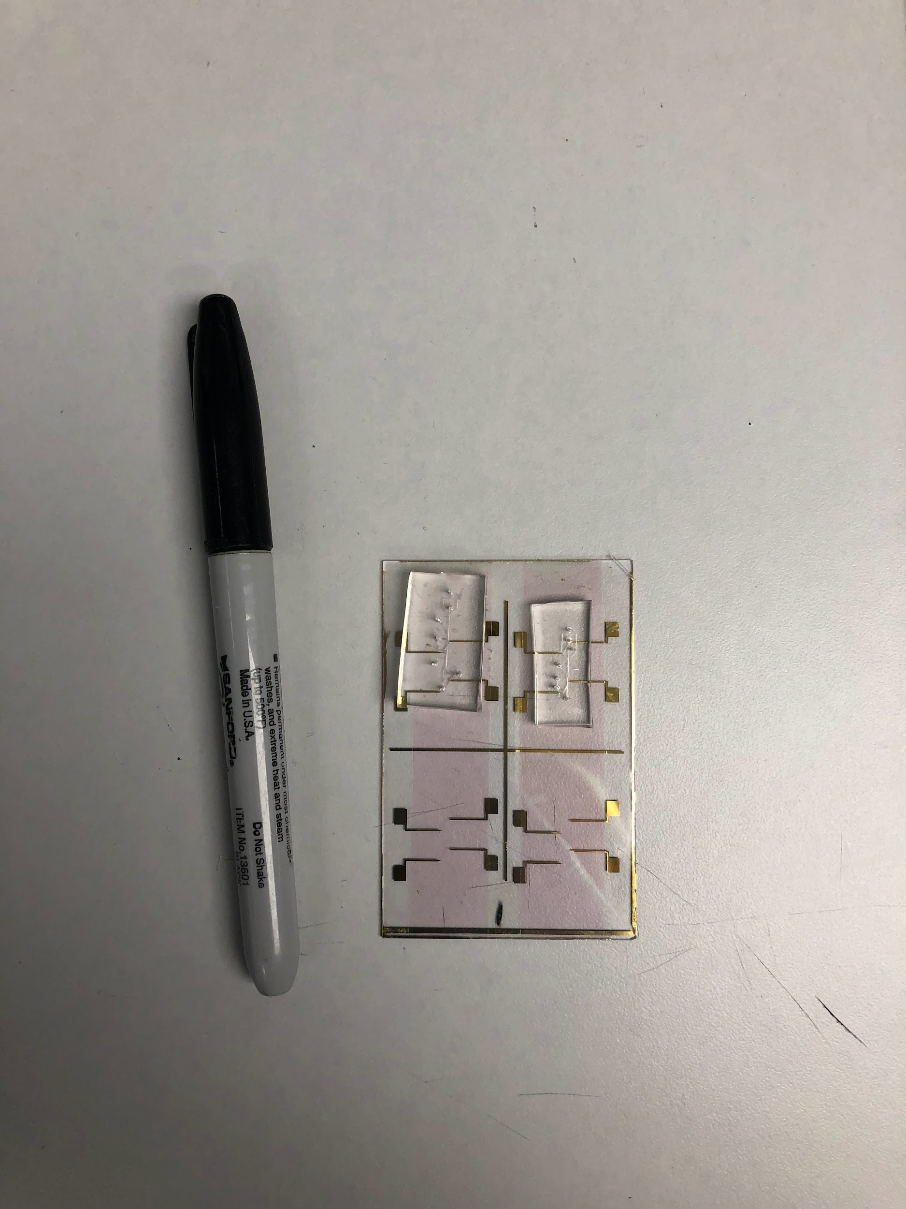

*Figure 5: Top view of bonded device*

*Figure 6: Experimental setup from the left*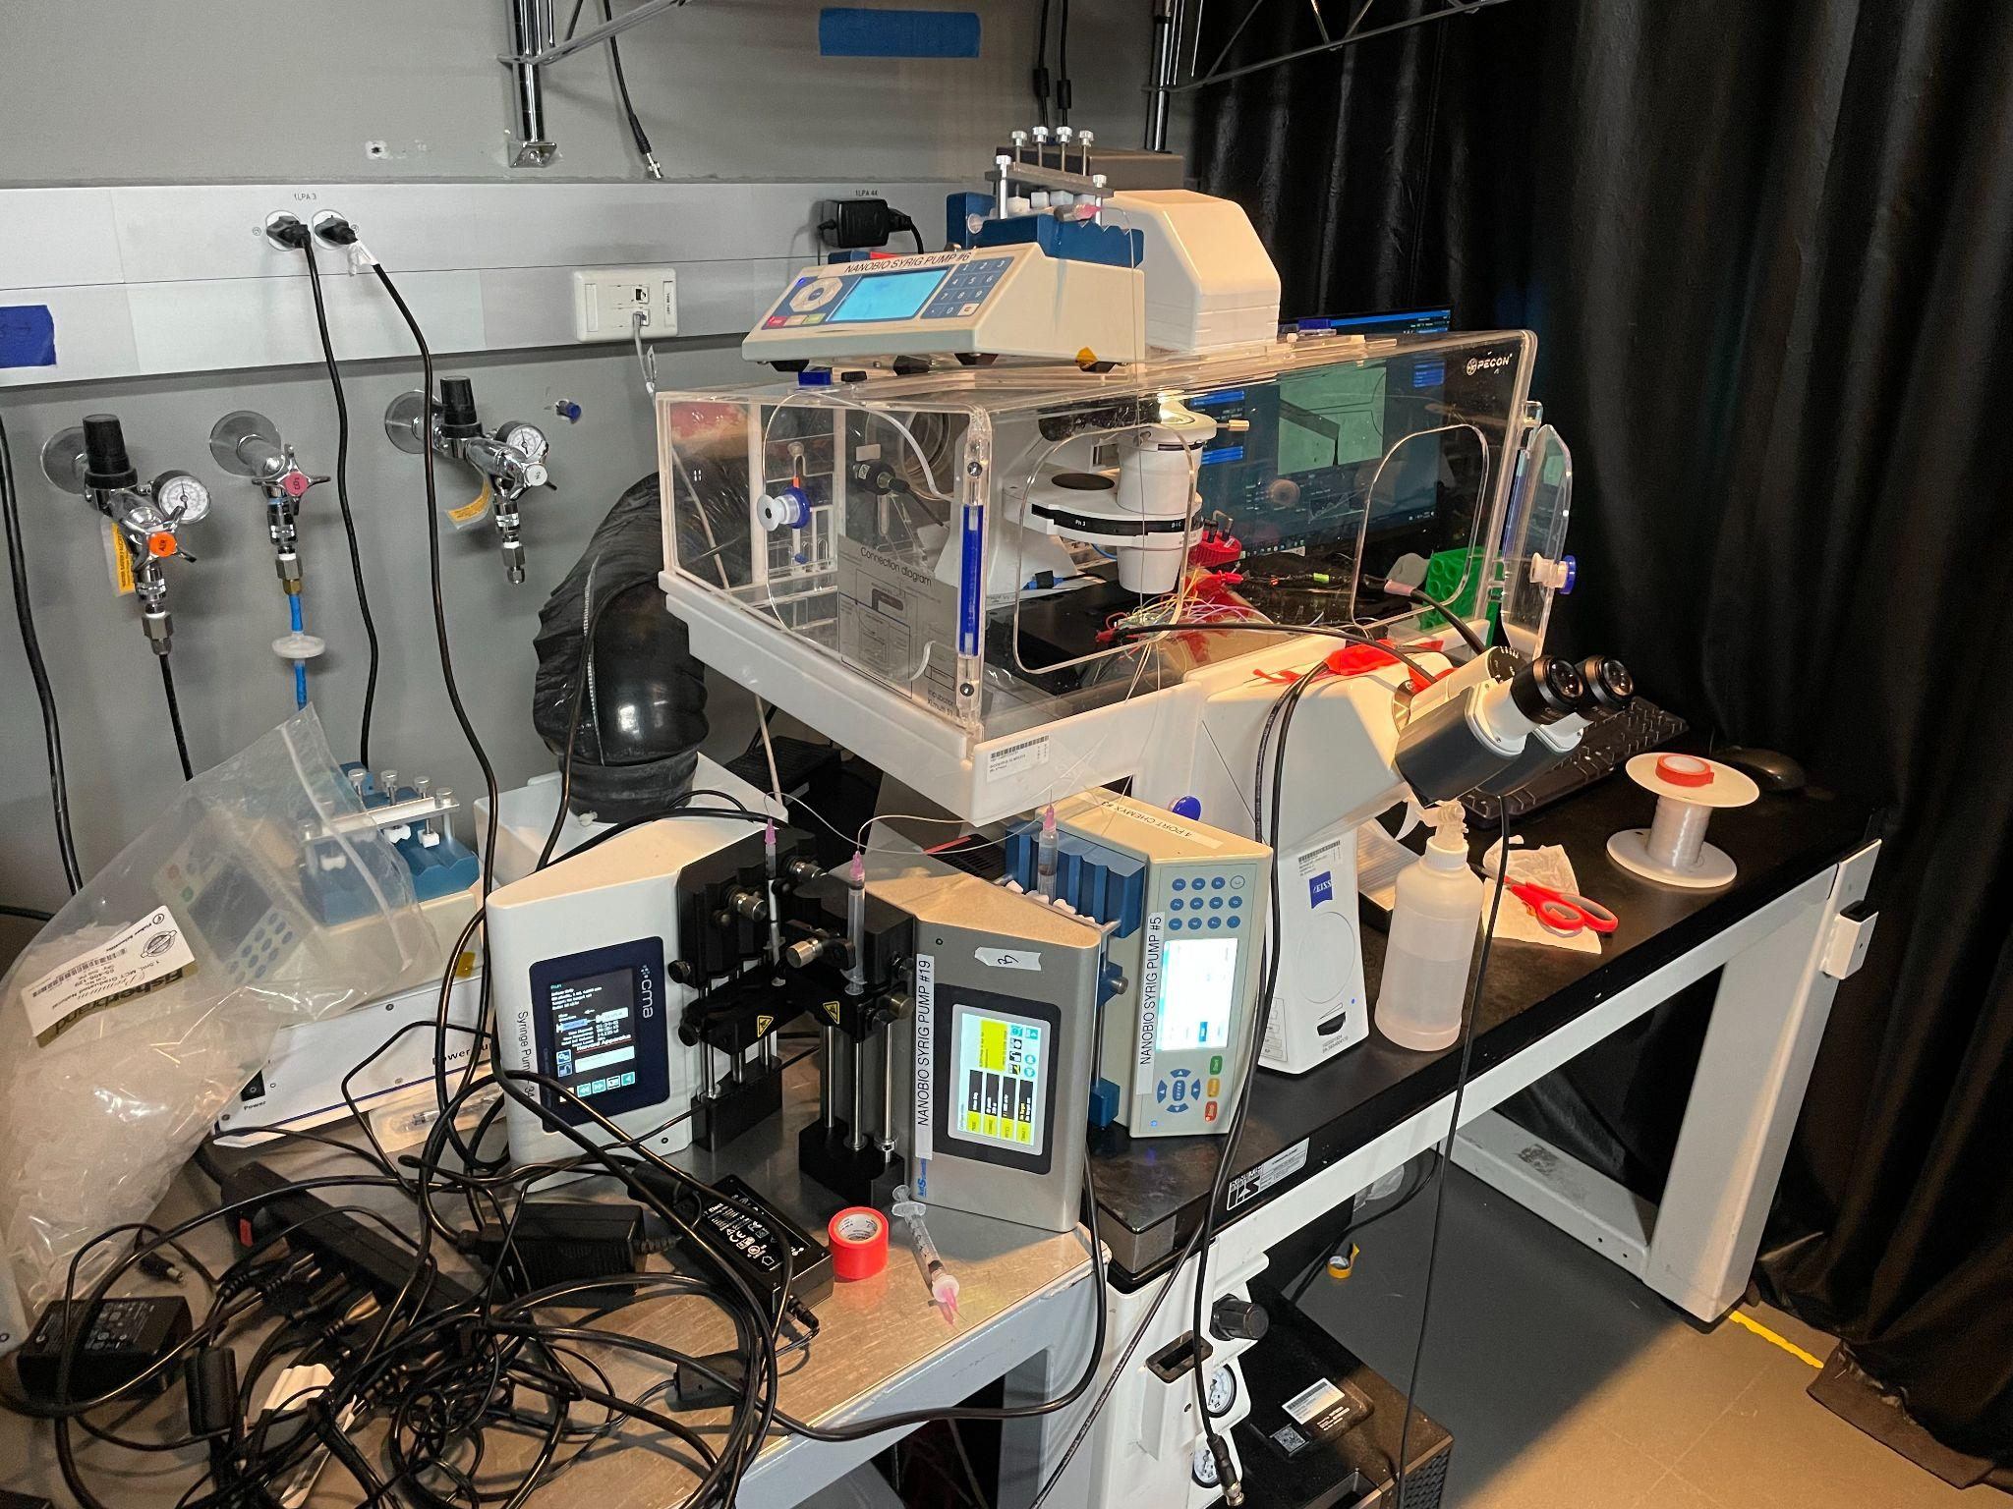

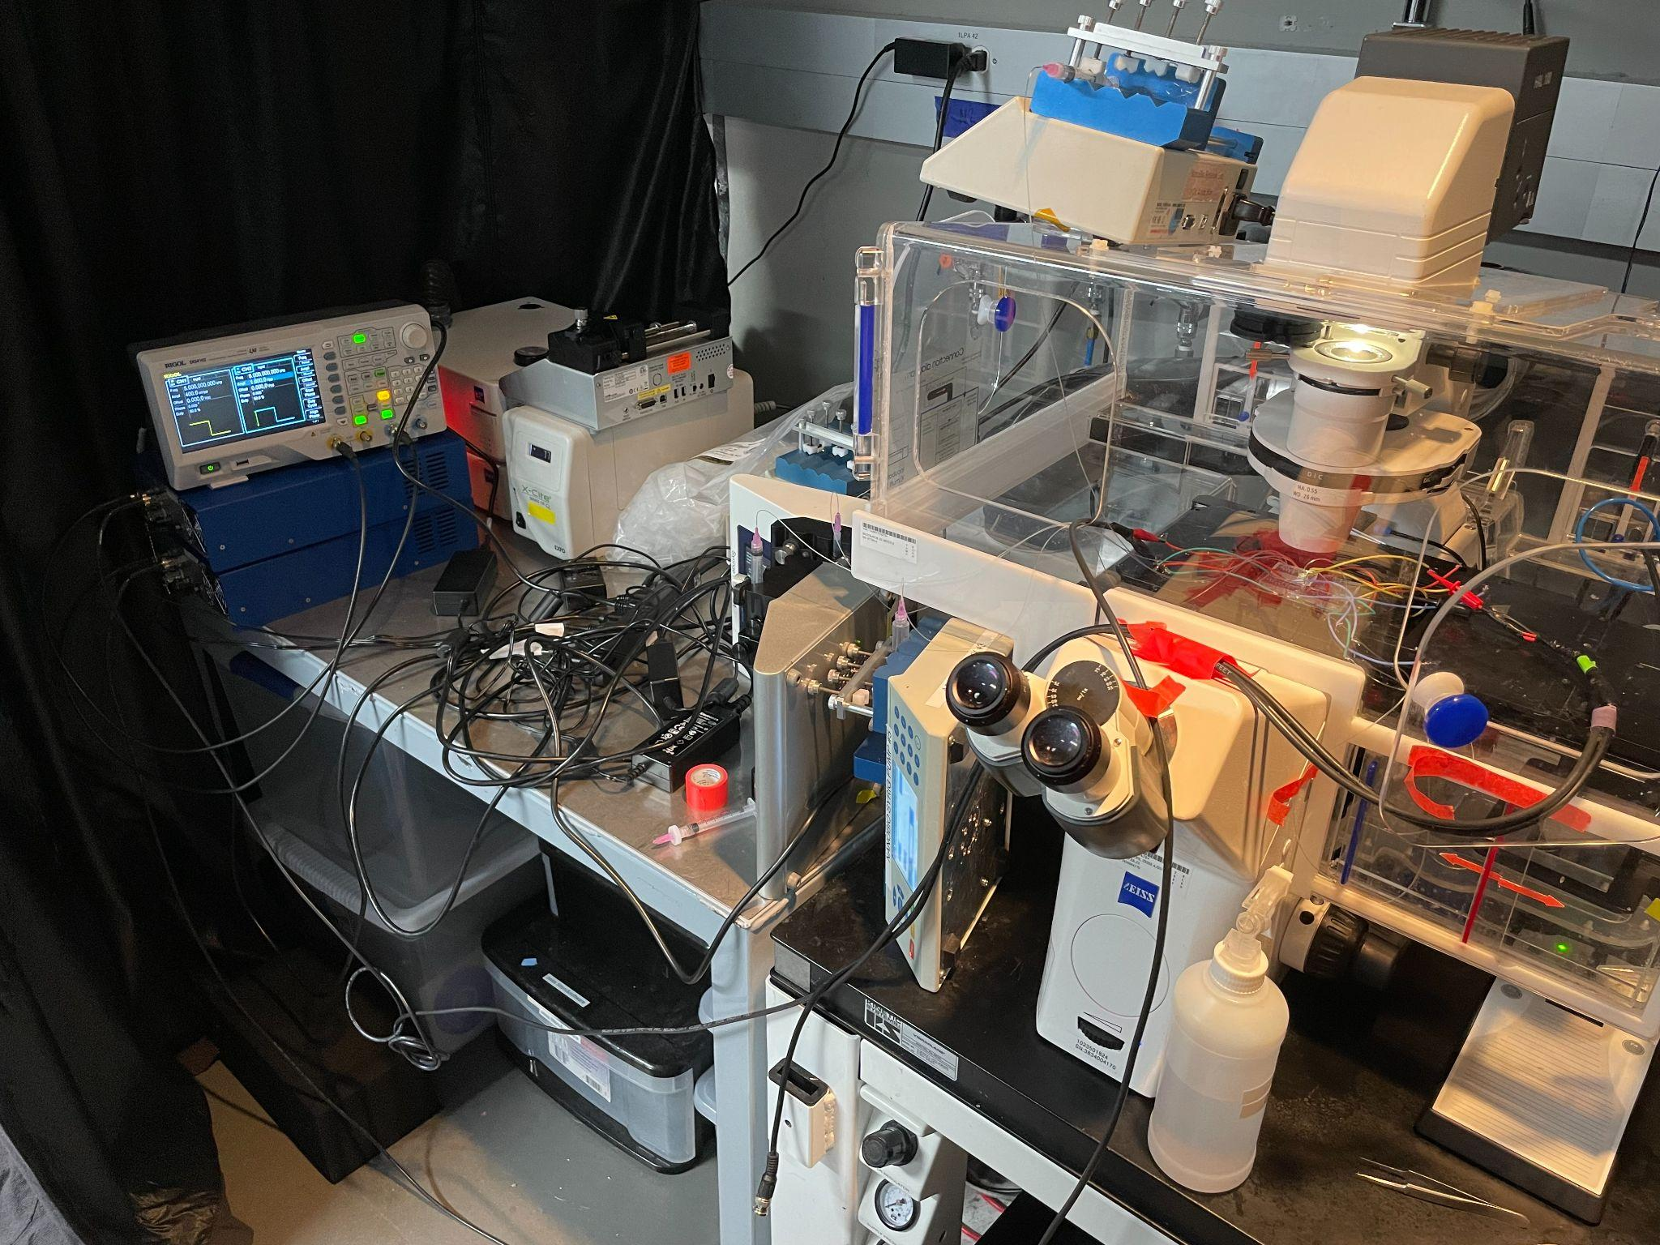

*Figure 7: Experimental setup from the right*

**4. Operation**

There were two primary stages of validation to ensure that the high pass filter was operating properly. The first phase was to ensure that the channel was fabricated correctly. This meant ensuring that there were no cracks or blockages in the channel and that the prescribed dimensions were correctly fabricated. This was done by passing fluids through the channel and viewing the process under a high powered microscope.

The second stage of validation was ensuring that the IDE fabrication was done correctly. There are a lot of factors that can affect the quality of fabrication. This was validated in a similar way to the channel, where the IDE was looked at under a heavy duty microscope and was checked for cracks and debris. A voltage was also passed through it to ensure that it worked.

At this point came full system integration. In full system integration, the channel was bonded to the IDE via a plasma bonder. This integration was the setting for the experiment. The larger droplets were dyed black to visually differentiate them. Droplets were passed through the channel and the IDE was activated and sorted them based on size successfully.

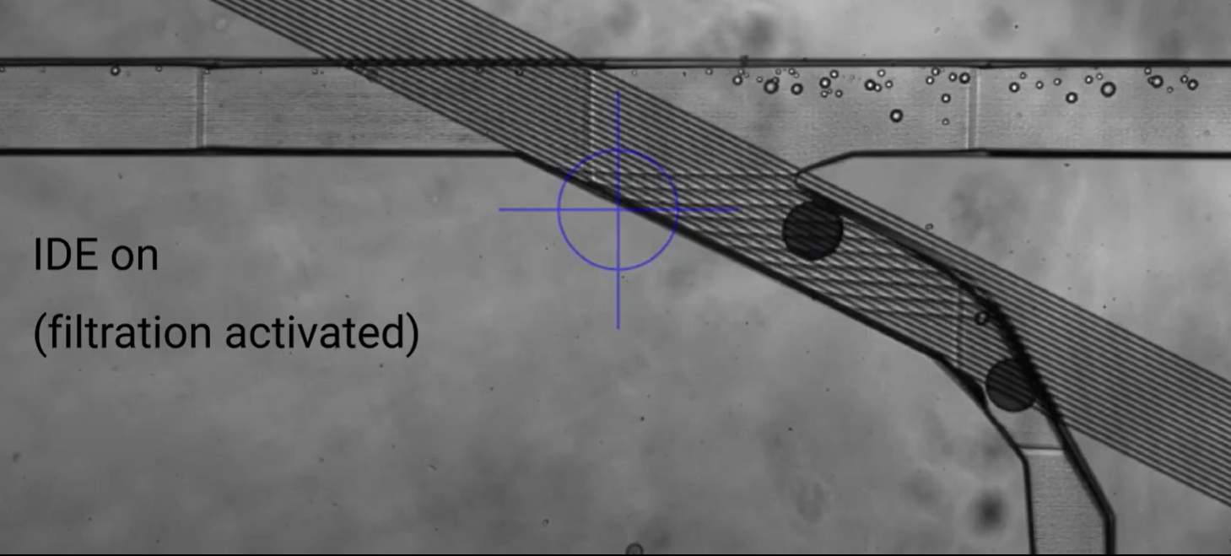

*Figure 8: Droplets being sorted using the device*

**5. Data Collection**

The validation of both individual phases of the filter were more qualitative than quantitative. The validation of the full system can be found in Table 1. A sorting accuracy of 90% was acceptable for the lab and an accuracy of 100% was considered excellent. From this table, it is clear to see that the accuracy achieved meets the requirement set forth by the lab. The average efficiency for all trials is around 96%.

| Trial | Total number of droplets 100um+ created | Droplets 100um+ that were sorted | Droplets 100um+ that were not sorted | Number of droplets less than 100um that were sorted |
| --- | --- | --- | --- | --- |
| 1 | 100 | 94 | 6 | 0 |
| 2 | 200 | 192 | 8 | 0 |
| 3 | 250 | 240 | 10 | 0 |
| 4 | 500 | 486 | 14 | 0 |
| Total | 1050 | 1012 | 38 | 0 |

*Table 1: Table of experimental results*

**6. Conclusion**

The high pass filter is an integral component of the microfluidic parser because it works closely with the other subsystem and produces the system's primary output and is required for the other subsystem to work correctly.

**6.1 Learnings**

Over the course of working on this subsystem, valuable knowledge was gained in several areas. In addition to learning about the field of microfluidics, one of the most important learning outcomes was the fabrication process and different methodologies associated with it. I had zero practical experience with fabrication, but it quickly became the backbone of the high pass filter. Along with the fabrication came the reinforcement of principles of electromagnetic fields. Software such as COMSOL Multiphysics and AutoCAD also became important assets. Lastly, important lessons were learned in teambuilding and the importance of proper communication.

**6.2 Future Works**

This semester served as a proof of concept for the high pass filter. Next semester, different parameters of the IDE will be tested. These parameters include different widths and spacing between the fingers of the IDE. The difference that these changes bring will be observed. Another goal for next semester is to try to bring the accuracy up to around the 100% mark. This will be good because it would eliminate the waste of good droplets as well as the removal of satellite droplets. Next semester, we will also try to combine the high pass filter with the bandpass filter with an intermediate process such as PCR.